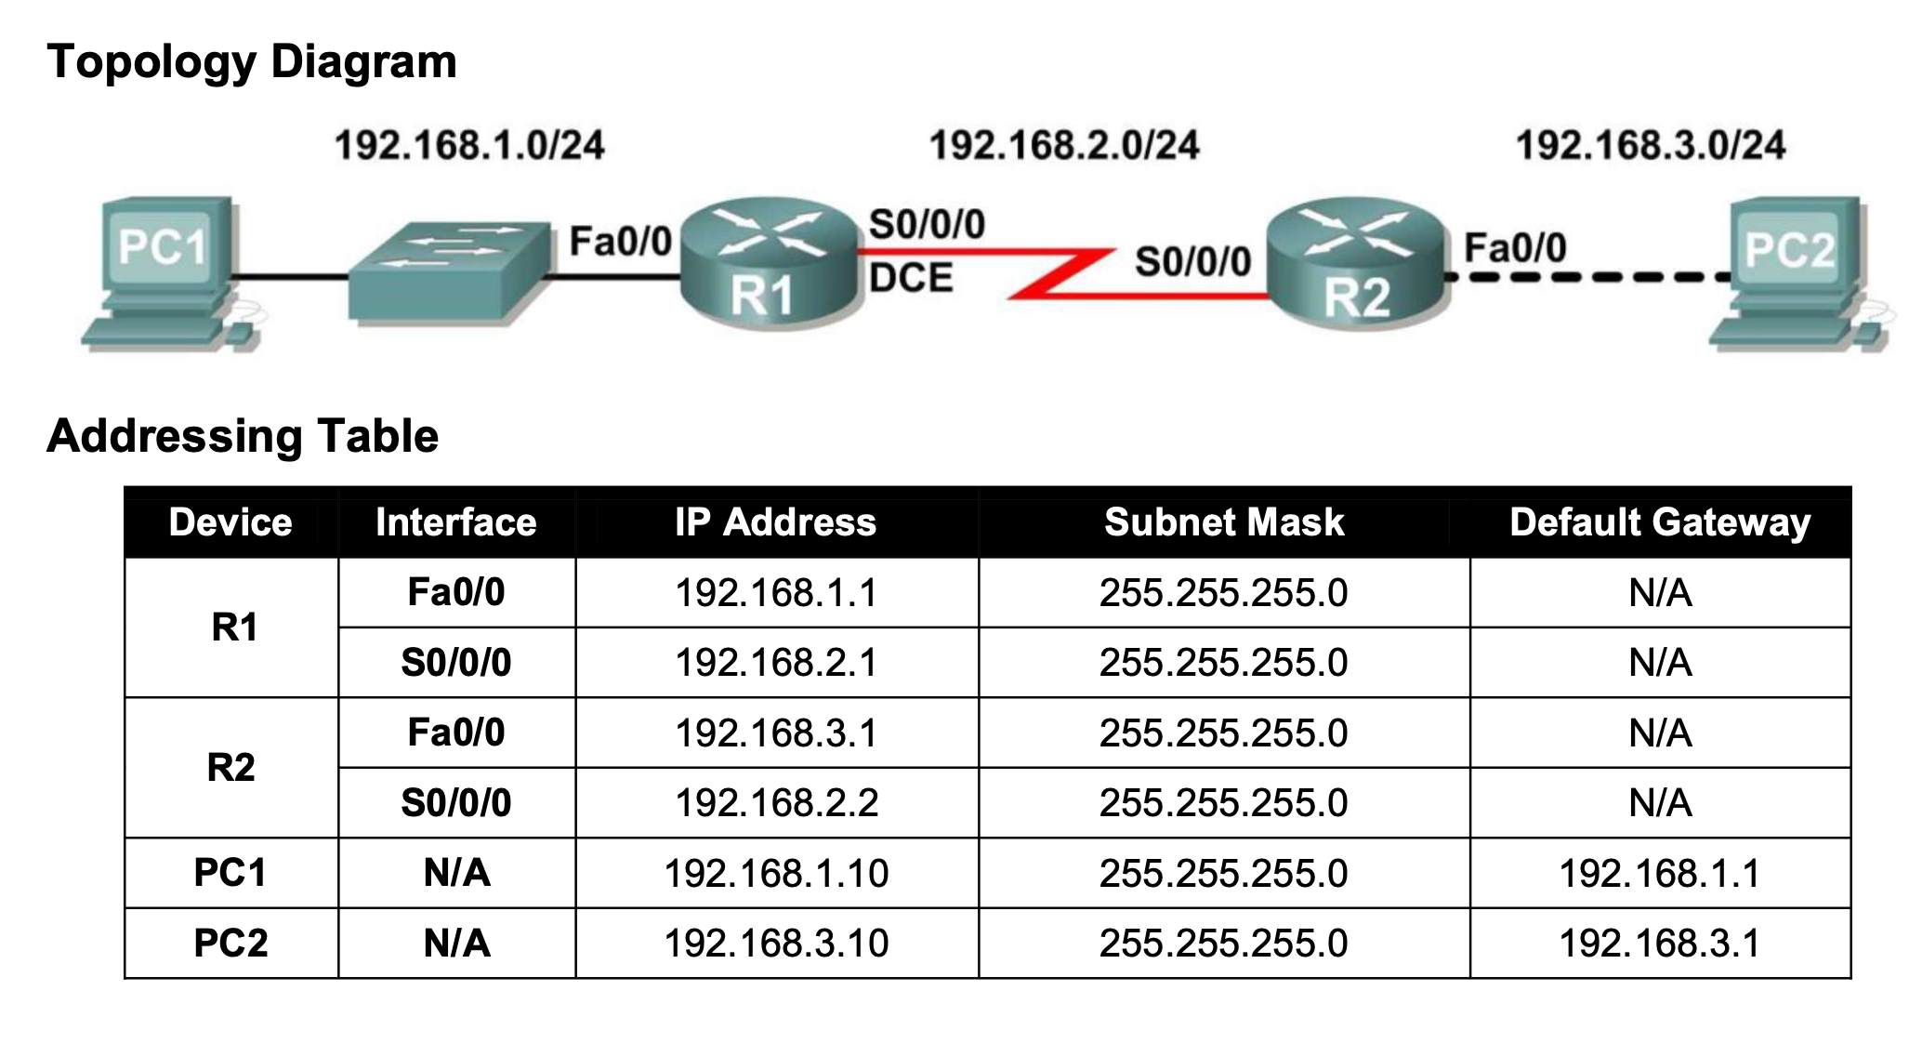

Cables required

Copper cross over cable ------------------

Copper straight Through ____________

Serial DTE / Serial DTC

R1 Commands

Router>en

Router#config t

Enter configuration commands, one per line. End with CNTL/Z.

Router(config)#hostname R1

R1(config)#line console 0

R1(config-line)#password cisco

R1(config-line)#login

R1(config-line)#exit

R1(config)#line vty 0 4

R1(config-line)#password cisco

R1(config-line)#login

R1(config-line)#exit

R1(config)#interface FastEthernet0/0

R1(config-if)#ip address 192.168.1.1 255.255.255.0

R1(config-if)#exit

R1(config)#interface Serial0/0/0

R1(config-if)#ip address 192.168.2.1 255.255.255.0

R1(config-if)#no sh

R1(config-if)#description R2 LAN

R1(config-if)#end

R1#copy running-config startup-config

R1#show running-config

R1# show interfaces fastEthernet 0/0

R1#show version

R1#show ip interface brief

____________

**R2 Commands**

Router>en

Router#config t

Enter configuration commands, one per line. End with CNTL/Z.

Router(config)#hostname R2

R2(config)#line console 0

R2(config-line)#password cisco

R2(config-line)#login

R2(config-line)#exit

R2(config)#line vty 0 4

R2(config-line)#password cisco

R2(config-line)#login

R2(config-line)#exit

R2(config)#interface FastEthernet0/0

R2(config-if)#ip address 192.168.3.1 255.255.255.0

R2(config-if)#exit

R2(config)#interface Serial0/0/0

R2(config-if)#ip address 192.168.2.2 255.255.255.0

R2(config-if)#clock rate 64000

R2(config-if)#no sh

R2(config-if)#description R2 LAN

R2(config-if)#end

R2#copy running-config startup-config

R2#show running-config

R2# show interfaces fastEthernet 0/0

R2#show version

R1#show ip interface brief

**Ping (Verify connection)**

Step 2: Repeat the ping from R1 to PC1.

R1#ping 192.168.1.10

Step 2: Use the tracert command at the Windows command prompt to discover the path that a packet will take from the R1 router to PC1.

C:\>tracert 192.168.1.1

Erasing Router settings

R1#erase startup-config

R1#copy running-config startup-config

Test connection

R1#show ip route

R1#show ip int brief

**LAB 3**

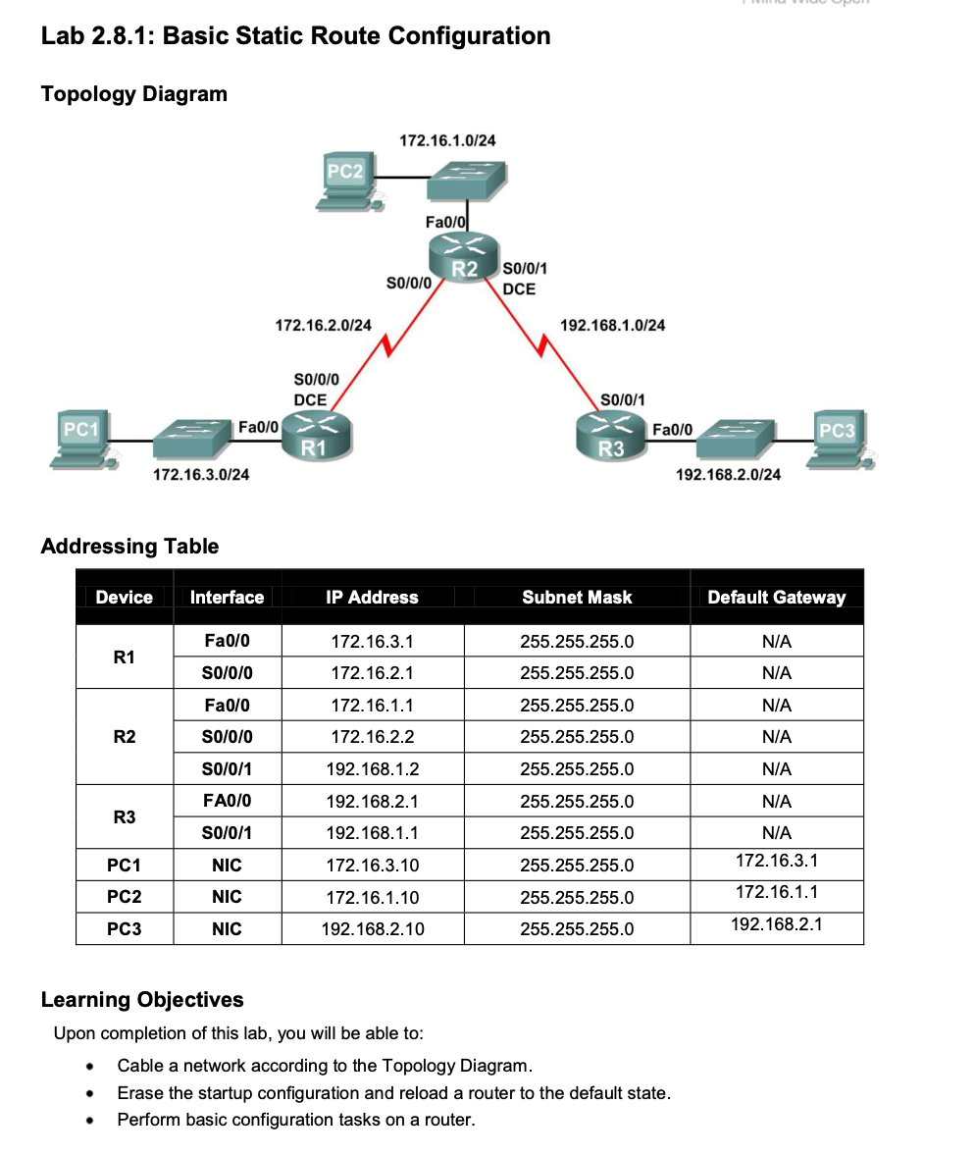

Router>en

Router>config t

Enter configuration commands, one per line. End with CNTL/Z.

Router(config)#

**Task 1: Cable, Erase, and Reload the Routers.**

Router#erase startup-config

Router#reload

**Task 2: Perform Basic Router Configuration.**

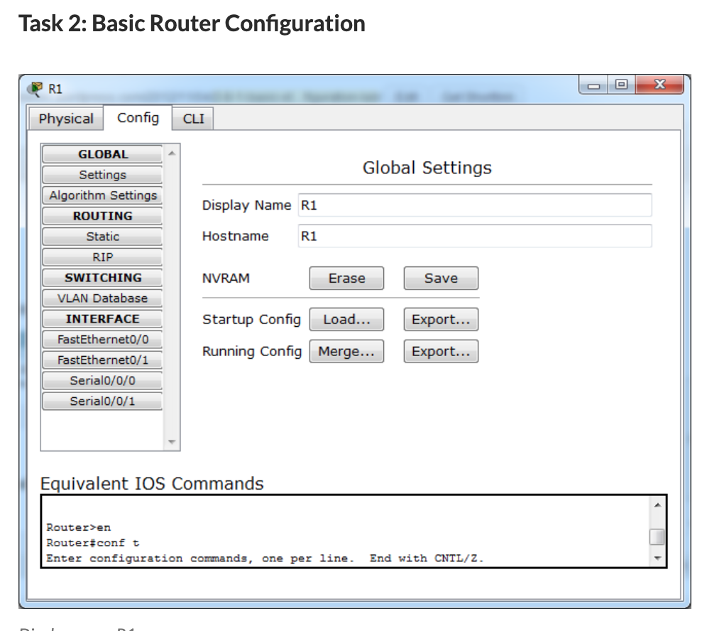

**R1- R2 – R3 - Configuration**

**Step 1: Use global configuration commands.**

Router1(config)#hostname R1

R1(config)#no ip domain-lookup

R1(config)#enable secret class

**Step 2: Configure the console and virtual terminal line passwords on each of the routers.**

R1(config)#line console 0

R1(config-line)#password cisco

R1(config-line)#login

R1(config-line)#exec-timeout 0 0

R1(config-line)#line vty 0 4

R1(config-line)#password cisco

R1(config-line)#login

R1(config-line)#exec-timeout 0 0

R1(config-line)#logging synchronous

**Step 3: Add the logging synchronous command to the console and virtual terminal lines.**

**Repeat the same commands for R2 and R3**

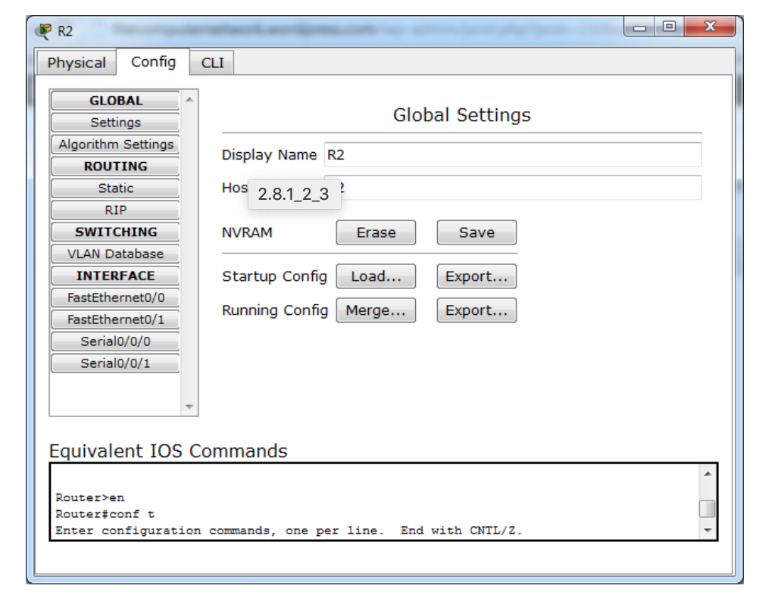

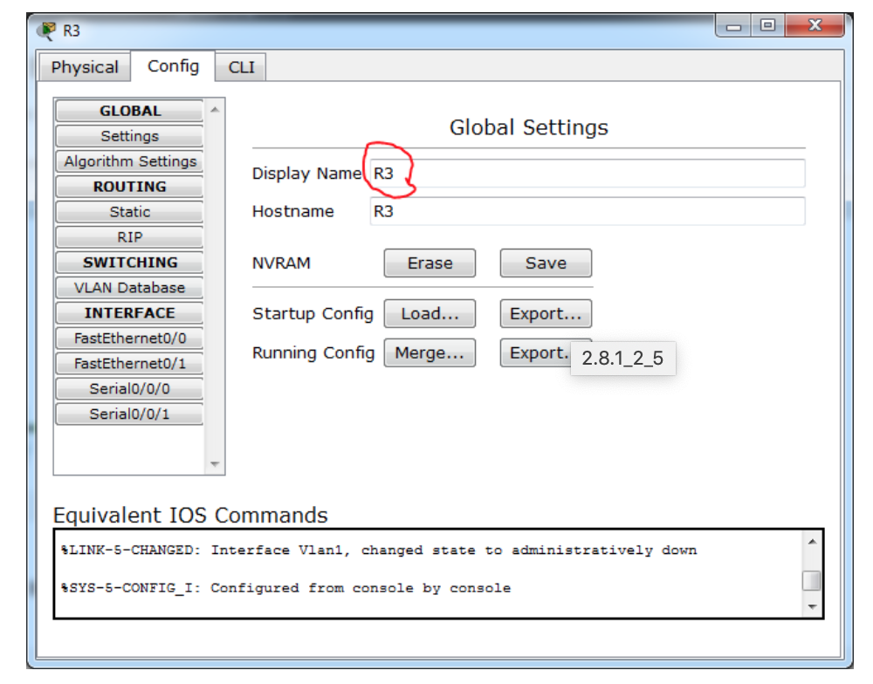

**Task 3- configure interface router**

R1(config)#interface fa0/0

R1(config-if)#ip address 172.16.3.1 255.255.255.0

R1(config-if)#no sh

**Configure Serial port**

R1(config)#interface s0/0/0

R1(config-if)#ip address 172.16.2.1 255.255.255.0

R1(config-if)#clock rate 64000

R1(config-if)#no sh

R1(config-if)#description

***R2 Interface***

R2(config)#interface fa0/0

R2(config-if)#ip address 172.16.1.1 255.255.255.0

R2(config-if)#no sh

*Configure serial ports*

R2(config)#interface s0/0/0

R2(config-if)#ip address 172.16.2.2 255.255.255.0

R2(config-if)#no sh

R2(config)#interface s0/0/1

R2(config-if)#ip address 192.168.1.2 255.255.255.0

R2(config-if)#clock rate 64000

R2(config-if)#no sh

***R3 Interface***

R3(config)#interface fa0/0

R3(config-if)#ip address 192.168.2.1 255.255.255.0

R3(config-if)#no sh

R3(config)#interface s0/0/1

R3(config-if)#ip address 192.168.1.1 255.255.255.0

R2(config-if)#no sh

**The subnet mask of PC1 is wrong. In real world, should be 255.255.255.0**

**Pc 1**

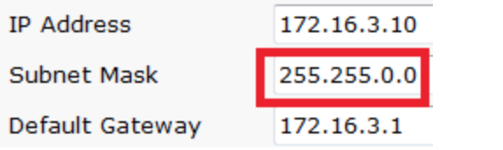

**The subnet mask of PC2 is wrong. In real world, should b 255.255.255.0**

**Pc2**

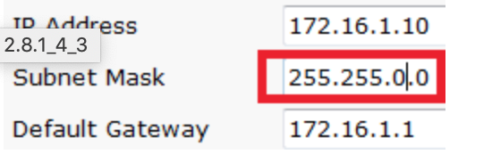

**Pc 3**

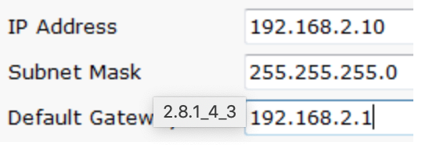

**Static Routing**

R1(config)#interface Serial0/0/0

R1(config-if)#ip route 0.0.0.0 0.0.0.0 172.16.2.2

R1 with default route

R2(config)#ip route 192.168.2.0 255.255.255.0 192.168.1.1

R2(config)#ip route 172.16.3.0 255.255.255.0 s0/0/0

R2 with next hub and exit interface

R3(config)#ip route 172.16.0.0 255.255.255.0 192.168.1.2

R3(config)#ip route 172.16.2.0 255.255.255.0 Serial0/0/1